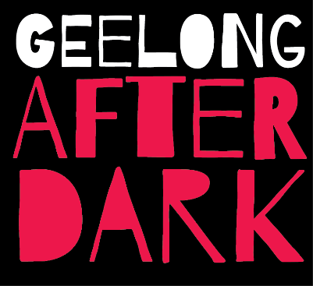

Date: Friday 3 May Central Geelong 6:0pm – 10:00pm

20 word descriptor
• Explore the artistic heart of Geelong as you discover the laneways, hidden spaces and cultural buildings at Geelong After Dark.

40 word descriptor
- Geelong After Dark is Geelong’s own night of arts. Held annually, artists embrace the theme to create for your viewing pleasure site-specific artworks. Interactive art; street performances, installations, music, exhibitions, projections and more. In 2019 Heighten Your Senses and abandon what you know.
50 word descriptor
• Geelong After Dark is an artistic exploration of the heart of Geelong. Held annually, the night is about entering and embracing the unknown. Discover the laneways, hidden spaces and cultural buildings After Dark. Experience interactive art; street performances, installations, music, exhibitions, projections and more. In 2019 Heighten Your Senses and abandon what you know.
Social Media feeds
#GAD19 for Instagram
@Geelongafterdark for Facebook
Lantana – image by Reg Ryan. Geelong After Dark 2018
